2. F. LIPIDS
Background information
Lipids are a group of compounds characterised by not being soluble in water and being soluble in non-polar solvents. This is a very broad definition, so the term lipids includes a diverse range of compounds, including fats and oils, fatty acids, and soaps. Other lipids not covered in this course are waxes, steroid molecules, and phospholipids which make cell membranes. All lipids tend to have a significant chain of carbon atoms which causes them to be not soluble, and other more polar chemically active sites - predominantly acid and ester derivatives.
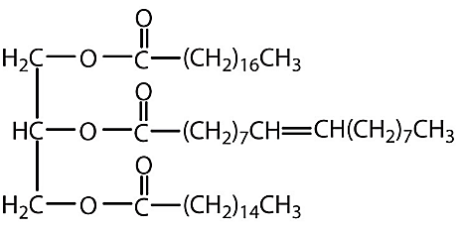
The most common type of lipid are the triglycerides. These are our fats and oils. Fats are triglycerides which are solid at room temperature, while oils are triglycerides which are liquid at room temperature. Fats tend to be found in animals, while oils tend to be found in plants. The differences in their melting point are related to structural differences in the molecules. All triglycerides have similar structures in that they are made from a single glycerol molecule (1,2,3-tripropanol) and three long chain carboxylic acids (fatty acids). The alcohol and acids groups react to form ester links between the three fatty acids and the single glycerol molecule.

Guide to making your notes
- Summarise the notes on trigylerides from the paragraph above. Draw the diagram fig 45.1 p.81, and beside it draw the diagram from above, labelling the glycerol part, the ester links, and the three fatty acids.
- Copy paragraph 3 p83 from your text - on the synthesis of triglycerides – with annotation. Note that glycerine and glycerol are different names for the same molecule (gotta love organic chem!)
- Summarise the notes on the RHS of page 81. These relate to the structure of fatty acids, which is the second half of SC 64. Include why this makes a difference to melting point.
- Do Questions : p. 83 – Q 1, Q 4 and p. 84 – Q 1
- Summarise para 2 on p. 85, include the diagram below it.
- Summarise the section “hydrolysis using alkali” and “Saponification - …” on p. 85. These two sections overlap somewhat.
- Summarise text on pages 86 and 87 (with the exception of “historical development of soap”). You should focus your work on how the negative fatty acid ion acts as surfactant and an emulsifier. The SC is phrased “explain how their cleaning action and solubility in hard water is related to their chemical structure”. The text covers cleaning action well, but not so much solubility. The solubility stuff is common sense however. Soaps have a charged and polar terminal carboxylate anion (COO⁻) so they are more soluble than the fatty acids they are made from. However the carnon chain is non-polar and not soluble in eater at all. That is why soaps dissolve the way described in your text on page 87. Given that all soaps have the same polar carboxylate anion (the negative COO⁻ part), the smaller the Carbon chain of the soap, the more soluble the soap is.
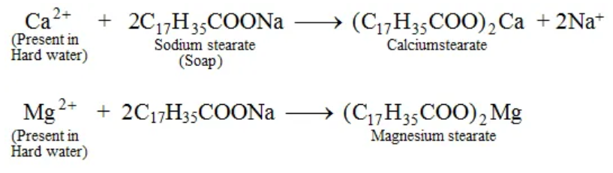
Hard water is water with a higher than normal concentration of multivalent cations - typically Ca⁺² and Mg⁺². These ions displace the sodium ion, and are attracted to more than one soap molecule – see diagram below. In doing so the ability of soap to dissolve in water is reduced. By attracting the carboxylate end of two or more soap molecules, these multivalent cations cause the charged and polar carboxylate anion to be at the centre of the larger molecule, rather than an exposed end of the smaller individual molecules. This configuration means the soluble part of the soap molecules are less open to interactions with water, and the attractive forces between the carboxylate anion and water are reduced. Soap often precipitates as a “scum” at the water edge when hard water is used. Soap does not lather as well in hard water for this reason as well.

- Do Questions: p.85 – Q1,Q2 a,b p. 87 – Q2c, Q3a, 6a,b

